JOHN MCGLASHAN COLLEGE
ENGLISH DEPARTMENT

IB English 2016 - 2017

Course and Assessment Handbook
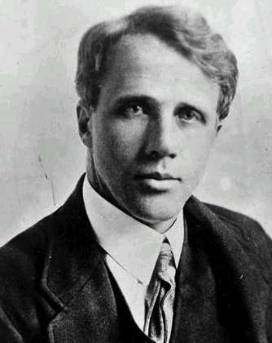
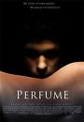
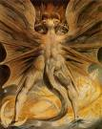
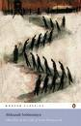

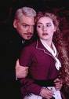
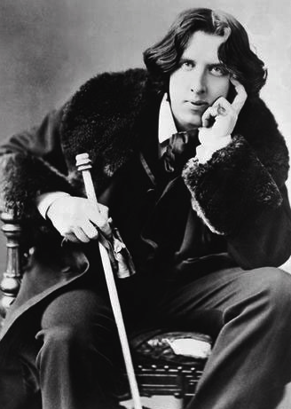
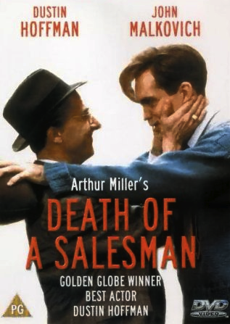
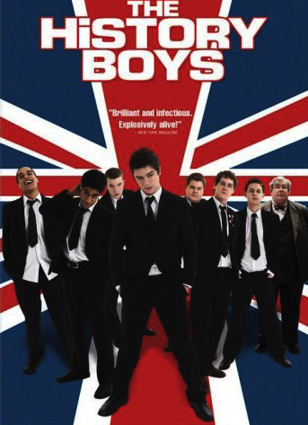

JOHN MCGLASHAN COLLEGE

IB ENGLISH 2014 - 2015

This is a two year course that enables students to work towards gaining their International Baccalaureate diploma.

This course is dedicated solely to the IB structure and no credits are available for NCEA Level 2 or 3.

Here is a summary of the four parts of the course:

Part | Details | Assessment Mode
1 | Works in Translation: study of 2 (SL) or 3 (HL) works translated into English from other languages. | External: a written assignment is done in school and it is sent away to be assessed.
2 | Detailed Study: study of 2 (SL) or 3 (HL) texts: one Shakespeare play, one short prose and one poetry. | Internal: oral commentary on extract from one text. Your commentary is recorded and assessed, then sent away to be moderated.
3 | Literery Genres: study 3 (SL) or 4 (HL) drama texts from different eras. | External exam: Paper 2: one essay question.
4 | Options study 2 (SL) or 3 (HL) texts: two poetry selections and one novels. | Internal: individual oral presentation.

There is one other exam: Paper 1. This is an unseen written commentary.

On the following pages are plans of the two years, with more detail about each of the parts of the course, indicating course content and assessment dates. You could gain an advantage by making sure you read the works ahead of time.

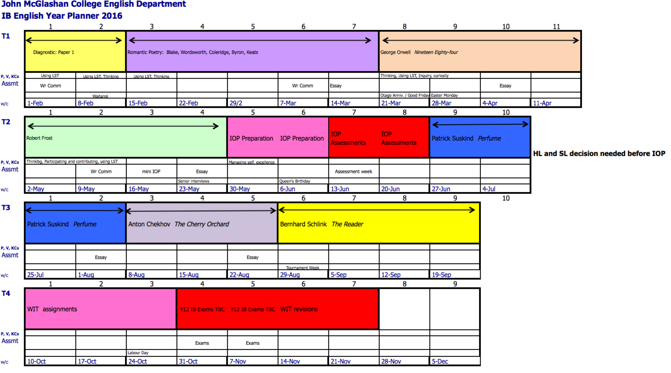

JOHN MCGLASHAN COLLEGE ENGLISH DEPARTMENT
INTERNATIONAL BACCALAUREATE PROGRAMME: LANGUAGE A LITERATURE
SEQUENCE AND PROPOSED COURSE CONTENT

Part Four Options
SL and HL: three works.
Assessment: individual oral presentation, internally assessed.
- Selected poetry from the Romantic poets: Blake, Wordsworth, Coleridge, Byron, Keats, Shelley.
- Nineteen Eighty-four George Orwell.
- Selected poetry of Robert Frost.

Part Four is taught first. The main focus is to develop your understanding of how literature works. It is assessed by an individual oral presentation. It covers a wide range of skills that you will need to succeed well throughout the course. These skills include:
- Essay writing.
- Commentary writing.
- Technical terminology.
- Language analysis.
- The use of secondary sources.
- Vocabulary building.
- Critical theory.
- Collaborative learning.

This section of the course is also designed to introduce you to studying across disciplines as well as TOK. For example, the following topics will be covered.
- Historical contexts: The Renaissance, The Enlightenment, Neo-Classicism, Romanticism…
- Other art forms, especially painting and music.
- Critical literacy
- Various “–isms” that philosophically underpin the texts we study, such as Marxism, totalitarianism, socialism, Romanticism…
- Language and symbolism; semiotics…

Part One Works in Translation
SL two works; HL: three works.
Assessment: essay(s) externally assessed; SL: one essay covering two works; HL: two essays covering three works. Three works will be selected from these:
- The Outsider Albert Camus.
- The Cherry Orchard Anton Chekhov.
- The Reader Bernhard Schlink.
- Perfume Patrick Suskind.
- One Day in the Life of Ivan Denisvich Alexander Solzhenitsyn.
- Chronicle of a Death Foretold Gabriel Garcia Marquez.

Part One is taught second. It is assessed by written assignment, which is written in school and sent away for marking. This area of the course emphasizes the internationalism of the IB course. The works were originally written in German, French, Spanish and Russian. Students can read the texts in the original as part of their Language B course.

Key skills taught in this unit include self-assessing and peer-assessing so as to identify future learning goals.

Part Two Detailed Study
SL: two works; HL: three works.
Assessment: SL: 10 minute individual oral commentary, recorded and assessed internally; HL: 20 minute individual oral commentary and discussion, recorded and assessed internally.
- One William Shakespeare play. Richard III, Romeo and Juliet, Macbeth or Antony and Cleopatra
- The war poetry of Wilfred Owen
- Selected short stories by Katherine Mansfield (HL)

Part Two is taught third, at the start of Y13. This is perhaps the hardest section of the course because of the assessment. You will deliver an individual oral commentary on a randomly selected extract from the above texts. It is very difficult indeed so much of the teaching is focused on speaking and discussion, rather than written skills.

This section of the course will revise and develop skills in critical analysis, which will help prepare students for the Paper 1 exam concurrently with the IOC assessment. To that end, many of the skills developed in Part Four are revisited and revised, most notably the following:
- Language analysis.
- Application of theoretical concepts.
- Genre and conventions.
- The importance of context.
- Vocabulary.
- Language terminology.

Part Three Literary Genres
SL: three works; HL: four works.
Assessment: written exam (one essay)
Genre: drama
- Hamlet William Shakespeare
- The Importance of Being Earnest Oscar Wilde
- Death of a Salesman Arthur Miller
- The Caretaker Harold Pinter (HL)

This part is taught last because it is assessed by written exam. There are two exams: Paper 1 is an unseen written commentary; Paper 2 is an essay based on at least two of the above works.

Again, essay writing and the importance of critical analysis are emphasised in this part. Students will work individually and in pairs to critique each other’s work.

