JOHN MCGLASHAN COLLEGE ENGLISH DEPARTMENT
INTERNAL ASSESSMENT 3.8 “LET’S GET CRITICAL”

THE WRITING PROCESS – KEY STRATEGIES 1

Key Strategy 1: Keep your notes / data chart detailed and up to date.
It is a vital tool for writing. Here is an example of some notes:

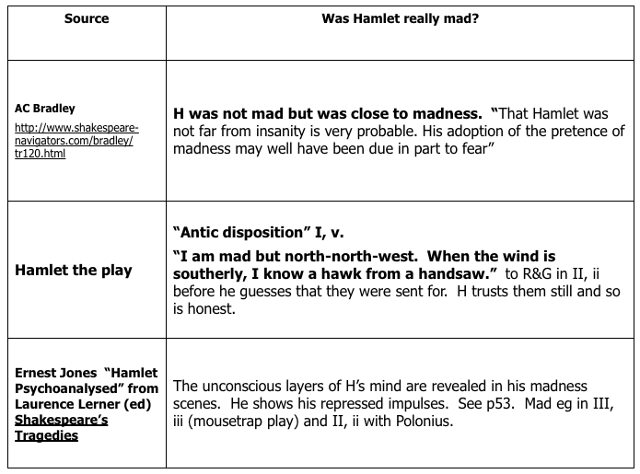

Key Strategy 2: Draft early. Make a start and add detail and polish later.
Get your main ideas sorted out. You can add in quotations and detailed, deconstructed examples later on if they are not obvious at first. Start by writing your abstract. Here is the example used in the slides:

Knowing a Hawk from a Handsaw: the Madness of Prince Hamlet

Abstract
“I am but mad north-north-west. When the wind is southerly, I know a hawk from a handsaw.” Hamlet’s confession to Rozencrantz and Guildenstern is often misinterpreted by unobservant audiences as meaning that sometimes he really is mad. Much has been written about Hamlet’s madness. Andrew Bradley boldly argues that Hamlet was not mad but was close to madness, while Harold Bloom is more subtle in his interpretation of “Shakespeare’s enigmatic intellectual” (Bloom, 1999 p 407). Bloom emphasises that Hamlet has been misinterpreted for four centuries and he himself describes the play as “a dance of contraries” (Bloom, 1999, p. 407). This essay will argue that Hamlet does not come close to madness; rather, he is completely and utterly in full possession of all his faculties throughout the play. He merely is meticulously careful about the personae he projects to the rank and gross unweeded garden of Denmark.

The above sentences are imperfect and lack polish, but they are a good start to help you sort out your over-arching thesis.

Key Strategy 3: Keep careful track of your sources.
Compile your bibliography as you go. Consult the Harvard referencing guide which is available as a download on the Weebly. Our library has this guides too. Use www.harvardgenerator.com with a little caution. Check the formatting it gives you. Here is the example of a bibliography.

Bloom, H., 1999. Shakespeare: the Invention of the Human. London: Fourth Estate.
Booker, C., 2004. The Seven Basic Plots: Why We Tell Stories. New York: Continuum.
Bradley, A.C., The Project Gutenerg eBook of Shakespearean Tragedy, by A.C. Bradley. [ONLINE] Available at http://www.gutenberg.org/files/16966/16966-h/16966-h.htm. [Accessed 04 April 2013].
Jones, E., Hamlet Psychoanalysed. In: L. Lerner, ed. 1968. Shakespeare’s Tragedies. Harmondsworth: Penguin. Ch. 5.
Shakespeare, W., Hamlet (Oxford School Shakespeare). Revised edition, 2007. Oxford: Oxford University Press.

Key Strategy 4: Develop your own ideas rather than merely paraphrasing
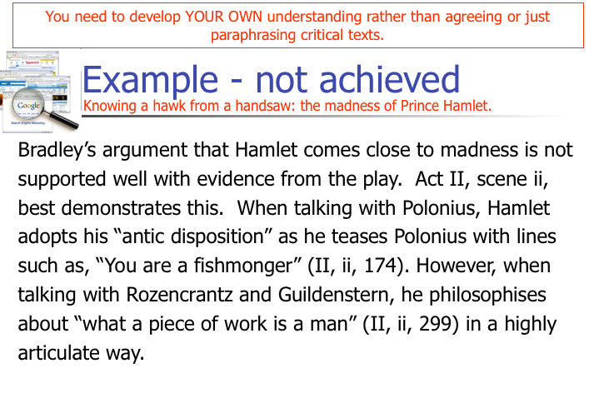

Key Strategy 5: Comment on the critical viewpoint and integrate your own ideas

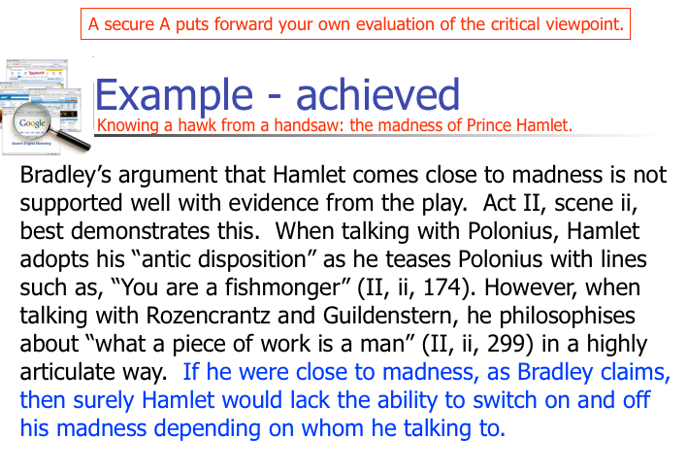

Key Strategy 6: Convince the marker by commenting on the most interesting point in the text.

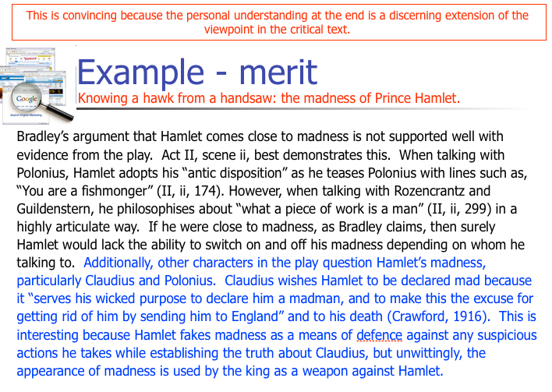

Key Strategy 7: Try to make perceptive and/or original points
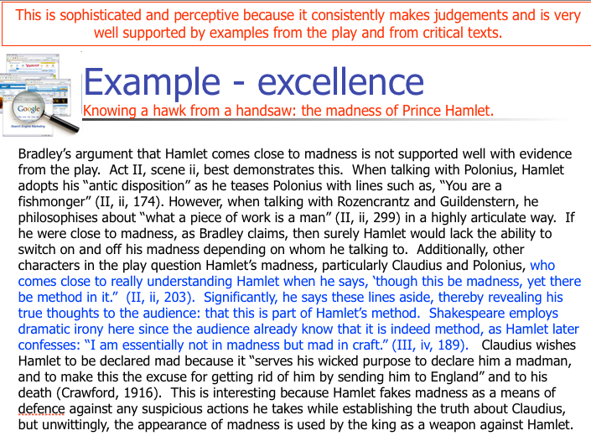

Key Strategy 8: Use effective connective phrases to develop the ideas in your paragraphs
These sentence starts below have been adapted from the work of Martin Davies of The University of Melbourne.
(a) Stating the view of another person:
- Smith claims that…
- Smith argues that…
- Smith’s conclusion is that…
- According to Smith (2008)…
- The substance of Smith’s article is that…
- Some critics such as Smith (2008) think that…
- It is thought by some theorists, for example Smith (2008) and Jones (2011) that…
(b) Stating the view of another person when you’re not quite sure:
- Smith’s claim seems to be that…
- Smith seems to be arguing that…
- From Smith’s point of view
- By applying Smith’s ideas, it can be concluded that…
(c) Drawing a conclusion from the work of others:
- The conclusion of this is that…
- A consequence of Smith’s claim is that…
- When Smith’s work is looked at closely, it can be seen that…
- When Smith’s argument is analysed, it is clear that…
- Analysing Smith’s work shows that…
- Developing Smith’s work to its logical conclusion shows that…
- From Smith’s work, it can be determined that…
- Using the work of Smith (2008) and Jones (2011) it can be argued that…
- The following argument can be brought out of Smith’s work…
- Using Smith’s work, it can ne concluded that…
(d) Disagreeing with the views of others:
- The argument against Smith is that…
- Unlike Smith, it can be claimed that…
- In contrary to Smith’s point of view…
- Problems arise in Smith’s work when it is seen that…
- Smith’s conclusion is not convincing because…
- It does not follow from Smith’s argument that…
(e) Agreeing with the views of others:
- As Smith argues…
- This is also Smith’s view…
- Not unlike Smith (2008), it is interesting that…
- This argument is supported by Smith’s work which states that…
- Following from Smith’s point…
- In agreement with Smith, in respect of his point that…
(f) Pointing out assumptions:
- Smith assumes that…
- Smith’s assumption is that…
- Assuming… then it follows that…
- The following assumption can be made here:
- This depends on the assumption that…
- Smith’s argument depends on the assumption that…

Key Strategy 9 – clearly demonstrate that you are not plagiarising.
The best way to paraphrase is to use the name of the author and the source in your sentence. They usually go at the start of the sentence such as this example. In Smith’s Hamlet: the Danish
Pope of Mope, he claims that… and at the end of the sentence, put the date that the work was published (2008).
If you do not mention the author’s name in the sentence, you must put it in brackets at the end of the sentence along with the date of publication (Smith, 2008).

Key Strategy 10 – meet the deadline. This needs no elaboration.

